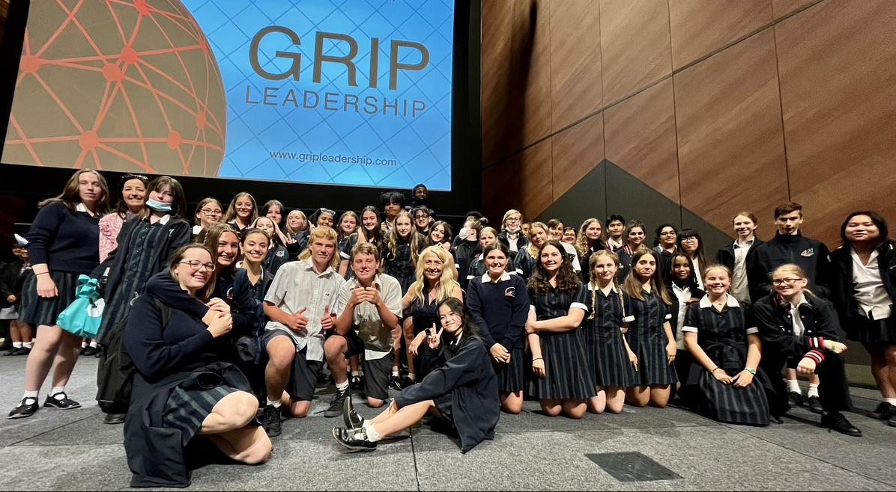

Essendon Keilor College High Achievers Program

EKC H.A.P

Respect Engage Aspire Learn

What is the EKC H.A.P program?

Our program has been developed to bring together like-minded, high-achieving students, giving them a sense of belonging and extending them to fulfil their potential. Through the combination of a specially designed curriculum, support from our experienced teachers and a culture of high expectations, students are nurtured, challenged and motivated towards achieving their highest level of academic excellence. Our mission here at Essendon Keilor College is to promote peak performance by delivering an outstanding education that is personalised and caters for varied interests, needs and aspirations.

At Essendon Keilor College, students undertaking this program will be accelerated in their subjects of English, Mathematics, Science, Humanities, Health and Physical Education, STEM, Horticulture, Art and Performance.

Students may also be eligible for the Victorian High Achievers Program, which provides opportunities for students to connect with like-minded peers across the state in order to reflect on their experiences and delve further into some of the big ideas of the course.

All students are expected to be involved in at least one extracurricular activity - Production, leadership, sports and/or music, to add a layer of global citizenship and community involvement to their learning experience.

All students successfully accepted into the program for 2023 will receive a laptop free of charge.

Students will also have the opportunity to apply for an EKC scholarship at each campus to cover the cost of uniforms and resources.
The program aims to strive for student excellence by:
- creating a more challenging learning environment for highly talented and motivated student
- providing the opportunity to work independently and cooperatively with other students of similar abilities and interests
- providing students who are academically inclined and motivated an opportunity to excel in their studies
- Developing strong and proficient skills in using ICT
- Developing sound personal and interpersonal learning to learn strategies
- Preparing students for a broader, more intensive VCE studies and/or University Extension units in their senior years.

Who should apply?

If your child is highly motivated, has a love of learning, is performing above the expected level, involved in extracurricular activities, then this is the program for them. The EKC H.A.P program is for students who desire to extend and challenge themselves in all areas of their schooling.

Student Selection Process

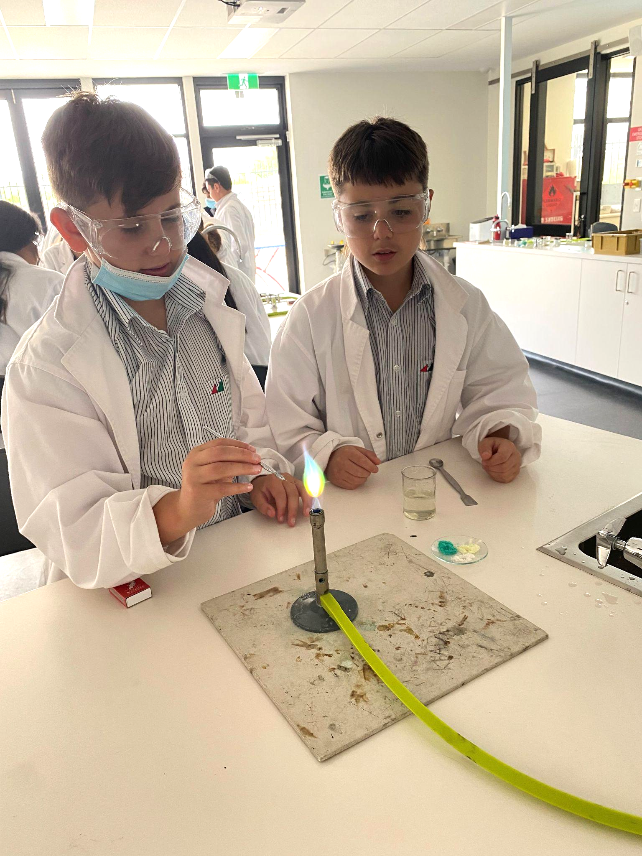
Students wishing to take part in the Essendon Keilor College H.A.P will be required to:

- Complete an online test evaluating the students' learning ability in English and Mathematics to demonstrate a minimum standard
- Write a personal letter of application
- Submit a reference from the student’s Primary School
- Submit Grade 5 NAPLAN results
- Participate in an interview on request

A maximum of 25 students will be enrolled in the EKC H.A.P class.

Timeline

STEP 1 | Secure a position at Essendon Keilor College Niddrie Campus or East Keilor Campus for year 7, 2023. Families will be notified of secondary school placements on Wednesday 20th July.
STEP 2 | Complete and return the confidential application to Essendon Keilor College by Wednesday 27th July.
STEP 3 | Student learning testing to be conducted at Essendon Keilor College on Wednesday 3rd August.
STEP 4 | Successful applicants will be notified in writing by the College Principal at the beginning of Term 4.

Please contact Christine Cole or Lisa Nugent for more information regarding Essendon Keilor College’s High Achievers Program for 2023.

